Week 1 Journal – System Planning & Distribution Selection
Module: Operating Systems
Assessment: Week 1 – Phase 1: System Planning and Distribution Selection

- System Architecture Diagram

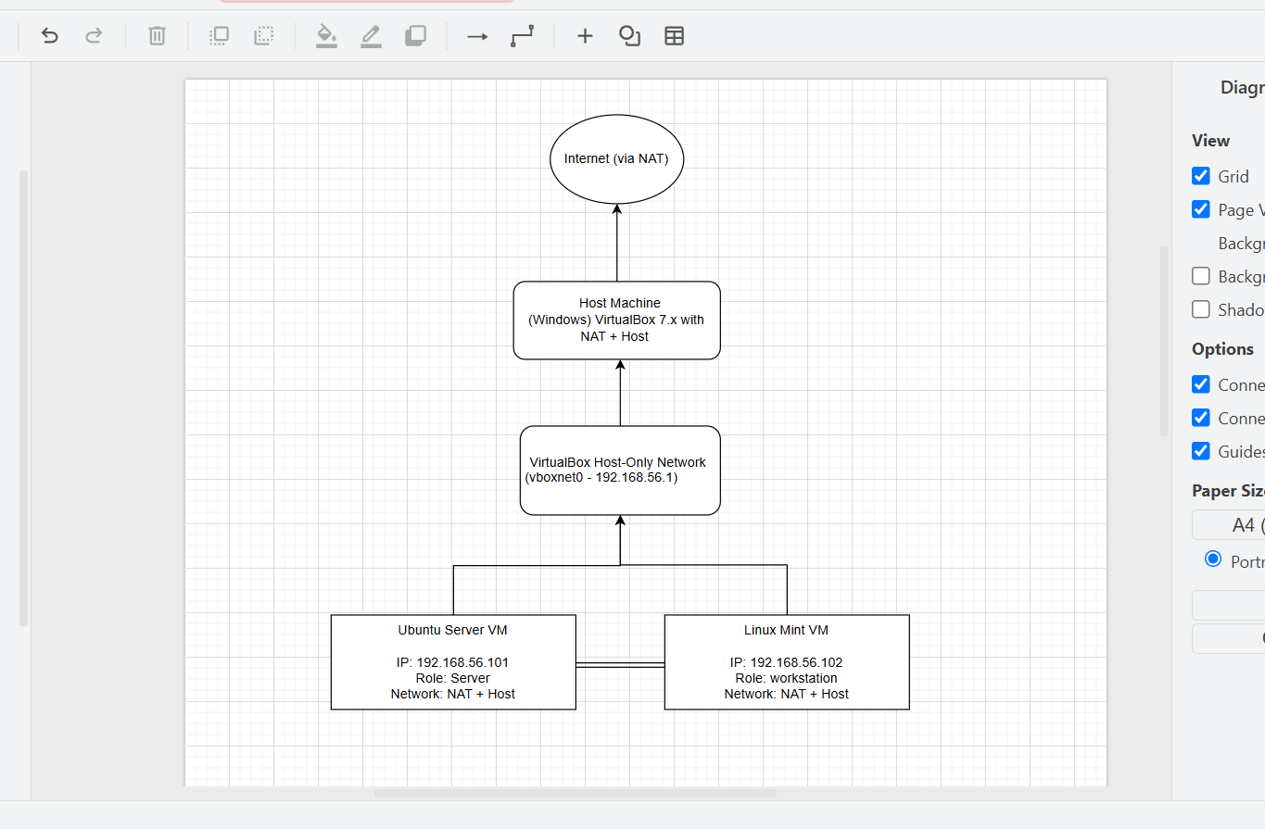
Notes:
I used my laptop as the host and set up two virtual machines inside VirtualBox. One is the Ubuntu Server, and the other is Linux Mint. I added both NAT (so they can use the internet) and Host-Only (so they can connect to each other). Each one got its own IP address 192.168.56.101 for Ubuntu and 192.168.56.102 for Mint. I tested both with ping and they worked fine.

- Distribution Selection Justification
Chosen Server Distro: Ubuntu Server 24.04.3 LTS
Alternatives Considered: Debian 12, Rocky Linux 9
Comparison:
- Ubuntu Server 24.04.3 LTS: Beginner-friendly, lots of documentation, frequent updates, easy networking setup.
- Debian 12: Very stable but older packages.
- Rocky Linux 9: Enterprise-grade stability but fewer desktop support tools.
Decision:
I chose Ubuntu Server 24.04.3 LTS because it’s stable, modern, and supported by a large community. It works well on my laptop, has simple commands, and fits the learning goals of the Operating Systems module.

- Workstation Configuration Decision
Chosen Workstation: Linux Mint 22.2 “Zara” (Cinnamon)
Reasons:
- User-friendly interface and very similar to Ubuntu (same base).
- Easier to take screenshots and access files.
- Perfect for practicing both GUI and terminal commands.
- Stable and lightweight enough to run smoothly in VirtualBox.

- Network Configuration
VirtualBox Settings:
- Adapter 1: NAT (Internet)
- Adapter 2: Host-Only Adapter → VirtualBox Host-Only Ethernet Adapter (192.168.56.1)
IP Addresses:
- The Ubuntu Server is configured with a Host-Only adapter and assigned the IP address 192.168.56.101. It serves as the main server in the setup.
- The Linux Mint virtual machine also uses a Host-Only adapter, with the IP address 192.168.56.102, functioning as a workstation.

Connectivity Tests:
From Server → Workstation: ping 192.168.56.102
From Workstation → Server: ping 192.168.56.101

- CLI Evidence – System Specifications
Ubuntu Server (192.168.56.101)
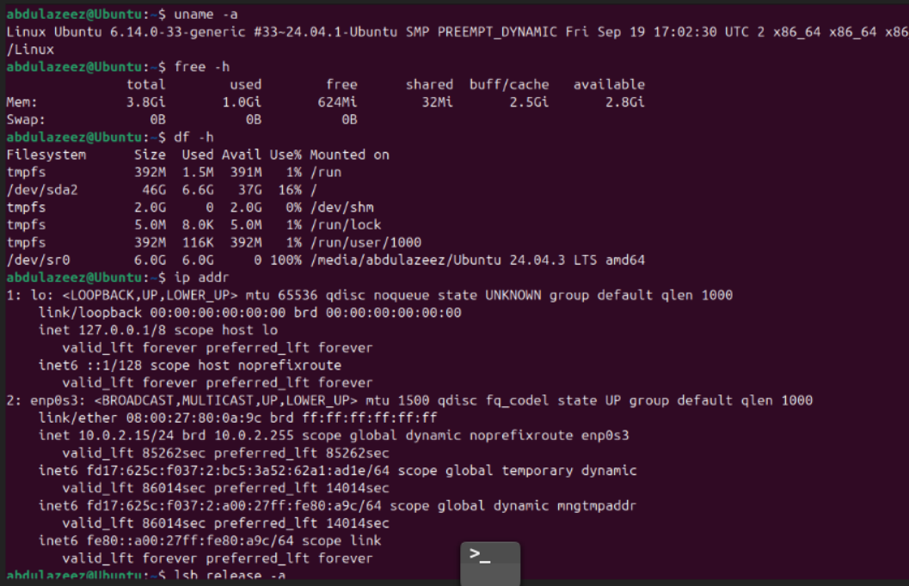
uname -a
Linux Ubuntu 6.14.0-33-generic #33~24.04.1-Ubuntu SMP PREEMPT_DYNAMIC Fri Sep 19 17:02:30 UTC 2024 x86_64 x86_64 x86_64 GNU/Linux
free -h
Mem: 3.8Gi used: 1.0Gi free: 624Mi swap: 0B
df -h
/dev/sda2 46G total, 6.6G used, 37G free (16%)
ip addr
inet 192.168.56.101/24 scope global dynamic enp0s3
lsb_release -a
Distributor ID: Ubuntu
Description: Ubuntu 24.04.3 LTS
Release: 24.04
Codename: noble

Linux Mint Workstation (192.168.56.102)

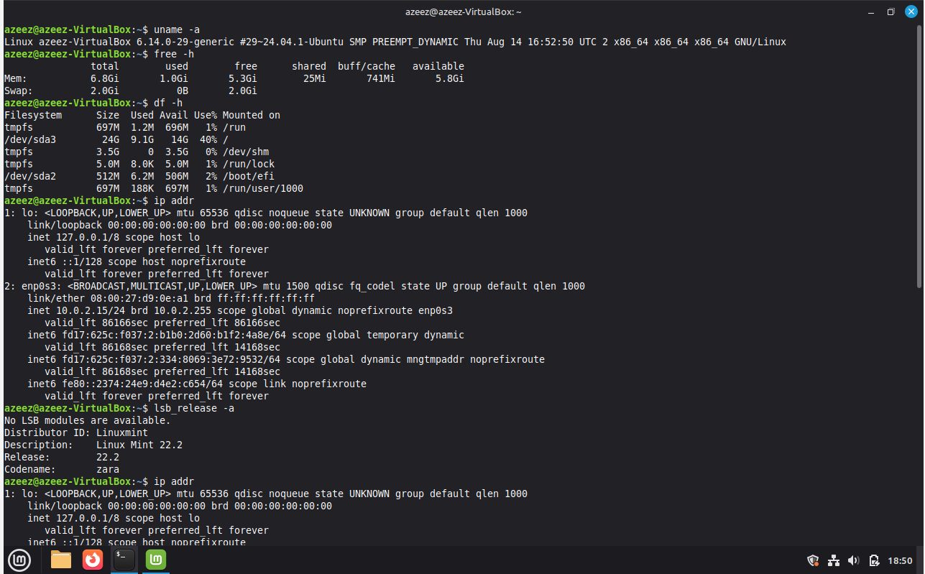

uname -a
Linux azeez@VirtualBox 6.14.0-29-generic #29~24.04.1-Ubuntu SMP PREEMPT_DYNAMIC Thu Aug 14 16:52:50 UTC 2024 x86_64 x86_64 x86_64 GNU/Linux
free -h
Mem: 8.6Gi used: 1.5Gi free: 3.5Gi swap: 2.0Gi
df -h
/dev/sda3 24G total, 9.1G used, 14G free (40%)
ip addr
inet 192.168.56.102/24 scope global dynamic enp0s3
lsb_release -a
Distributor ID: LinuxMint
Description: Linux Mint 22.2
Release: 22.2
Codename: zara

